Top Tourist Destination Places in Pradesh-5

* Lumbini : Lumbini is Lord Budhha's birthplace. It attracts Buddhist pilgrims from around the world. There are more than 25 monasteries here to visit built by different countries like

Vietnam, France and many more. We can study about Buddhism here too. Mayadevi is the most sacred place in Lumbini where there are footprints of Lord Buddha at the exact time he was born. The best time to visit Lumbini is in Winter. 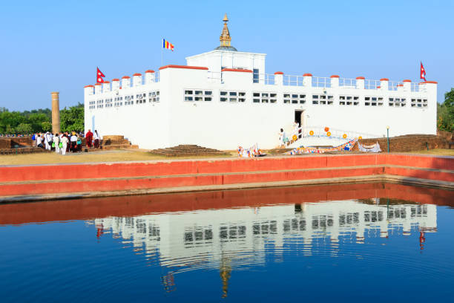

Best hotels to stay when in Lumbini:

* Tiger Palace Resort
* Lumbini Palace Resort
* Budhha Maya Garden by KGH Group
* Lumbini Buddha Garden Resort
* Bardiya National Park : It is the largest national park of Nepal. In the bank of Karnali, the longest river of Nepal, lies Bardiya National Park. The national park is home to endangered Royal Bengal Tiger, One Horned Rhinoceros, 30 species of mammals, varieties reptiles, 250 species of birds etc. The best time to visit here is autumn, winter or early summer.

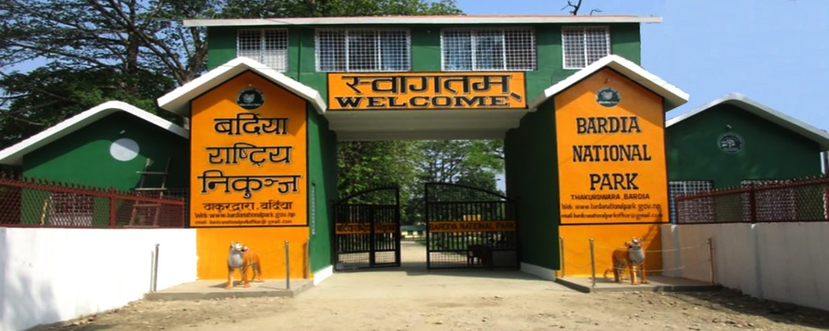

Best hotels to accommodate during Bardiya visit:

* Babai Resort Bardia National Park
* Bardia Tiger Resort
* Bardia Eco Lodge
* Palpa : Palpa showcases some old artistic Newari houses and cobbled streets. Exploring Shreenagar Hills, hike to Rani Mahal and streets of Tansen are the main attraction of Palpa. It lies in hilly region of Nepal. The Magar and Newari make up a large percentage of population in Palpa. Palpa can be visited at any time of the year as there is neither more hot or more cold temperature throughout the year.

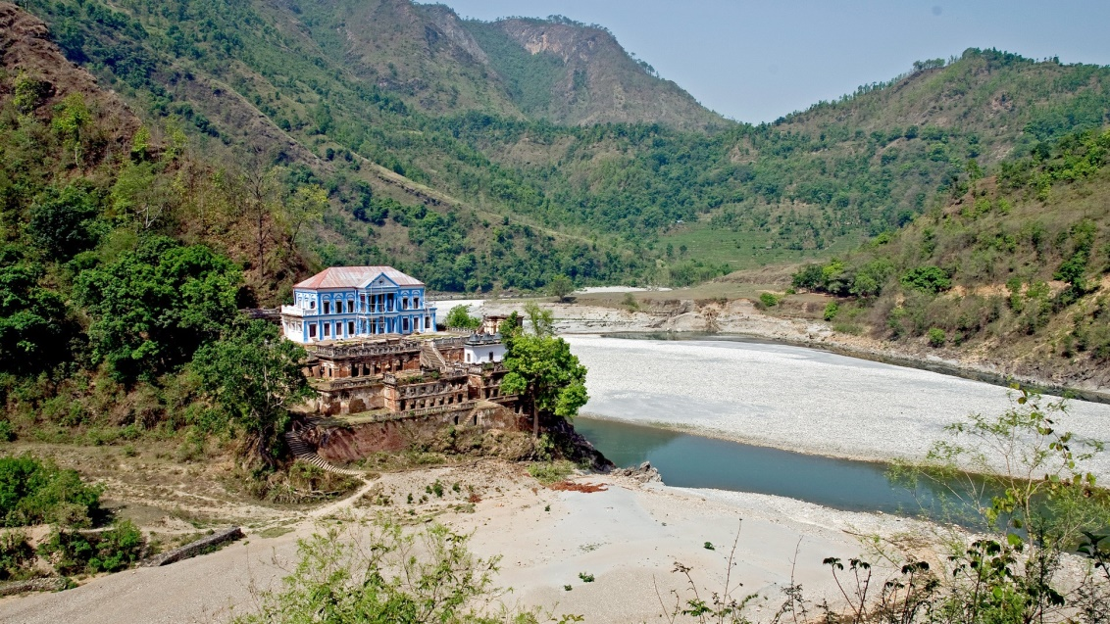

Best places to stay when at Palpa:

* Camping at river side in Rani Mahal
* Hotel Taj
* Hotel Srinagar pvt. ltd
* Supadeurali Temple : It is located in the center of Argakhanchi district. It is one of the most famous pilgrimages of Nepal lying at above 4500ft. It is a Hindu temple dedicated to Devi. It is surrounded from Hills from all sides. On every Saturday sacrifice of goat is done here. For accommodation you can choose to stay on local lodges near the temple. There aren't any high level hotels there.

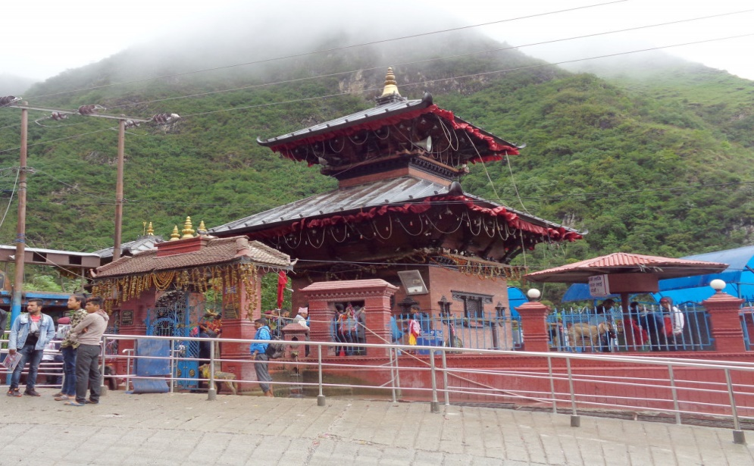

* Pakadi Tree : This tree is popularly known as "Koliya Tree". It lies in Sitalnagar Devdaha, Rupandehi district. It is 96 feet tall with diameter of 82 feet. It is the biggest tree of South Asia. Birds never nest on this tree, vultures and crow never perch on it and elephants never go near it. If you wish to visit this place than you can accommodate local hotel but if you wish for standard ones than you can go to Butwal city which is 11km away.

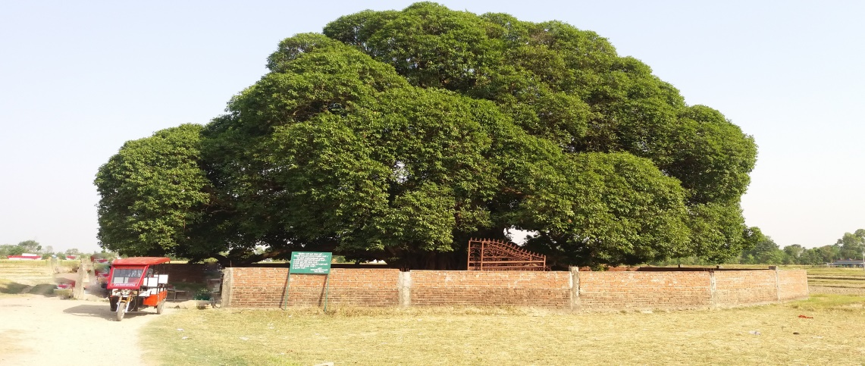

* Tiaurakot : It lies in the bank of Banganga river in Chure region at Kapilvastu district. Newfound evidences prove there was human settlement there 300 years ago before Gautam Buddha was born. Here, Lord Gautam Buddha spent 29 years of his lifetime. This site was listed as UNESCO tentative site in 1996. It is an important site for Hinduism. You can find a lot of local guest houses and hotels nearby.

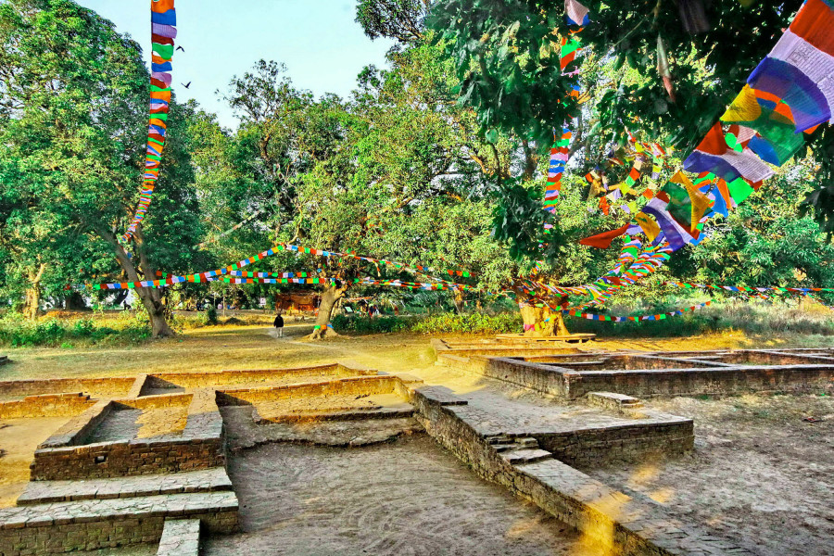

* Chitwan National Park : Chitwan National Park is the first National Park of Nepal and one of the 10 World Heritage Sites from Nepal listed by UNESCO. Tourists are attracted to this region for different activities: rafting, canoeing, elephant bathing and jungle safari. Jungle safari while riding on Elephant’s back is the most popular activity in this area where tourists can see various wild lives in their natural habitat. The visitors expect to see One-horned rhinoceros, Royal Bengal Tiger, Gaurs, Rock Python, King Cobra, Gharials, Hyenas, Sloth Bears and other wild species.

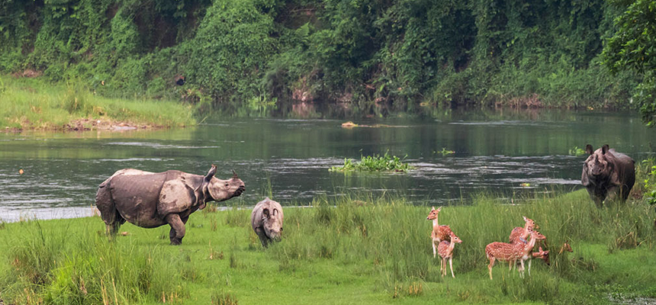

Best hotels to stay when in Chitwan National Park:

* Jungle Safari Lodge
* Barahi Jungle Lodge
* Hotel Wildlife Camp